

**EE4791 Database Systems**

Assignment Report

**Group Members:**

|  |  |  |
| --- | --- | --- |
| Name | Matric No. | Contribution |
| Zhu Han Zhuo | U1821264B | * Design database scenario * Draw ER diagram * Table structures(3NF) * Create tables and reports in Microsoft Access * Assignment Report |
| Yu Qihao | U1821897F | * Design database scenario * Draw ER diagram * Table structures(3NF) * Create queries and forms in Microsoft Access * Assignment Report |

Contents

1. Database Scenario

2. ER Diagram

3. Table Structures (3NF)

4. Table Designs

4.1 LIFEGUARD

4.2 LOCATION

4.3 SCHEDULE

4.4 CERTIFICATE EXPIRY

4.5 CERTIFICATE

4.6 ATTENDANCE

5. Queries

5.1 Attendance-Location

5.2 CERT_EXP

5.3 Schdule-Location

6. Data Entry Forms

6.1 Attendance

6.2 Attendance Subform

6.3 Certificate

6.4 CERT_EXP Subform

6.5 New Location

6.6 SCHEDULER

6.7 SCHEDULE Subform

7. Generated Reports

7.1 Cost of Lifeguard

7.2 Number of hours lifeguard worked

7.3 Lifeguard Certificate details

8. Future Improvements and Implementations

**8.1 Tables**:

8.1.1 Employee type, Lifeguard Payment Table

**8.2 Queries:**

8.2.1 Schedule-Location Query

**8.3 Forms:**

8.3.1 ATTENDANCE Form

**8.4 Reports:**

8.4.1 NOK-CONTACT Report

# Database Scenario

A lifesaving company started off its operation using manual data for many years. However, the company has been facing many issues in retrieving instantaneous reports regarding its lifeguard operation as the data is not recorded to a central database since its expansion to N number of locations and the employment of lifeguard.

Therefore, we are hired to help create a Database Management System, to increase their efficiency in handling their data. We propose a database that is able to register the following:

* Record of lifeguard particulars including: personal details, location of work, and lifesaving certificates.
* Each site to record the lifeguard work schedule.
* Records of Time- in/Time-out of lifeguards on duty.

The database must also be able to present reports on the following:

* Individual particulars, location.
* Monthly view of working schedules of lifeguards at each location.
* A report that flags out if any lifeguard has any of the certificates expiring in X month’s time.

# ER Diagram

|  |  |
| --- | --- |
| ATTENDANCE | |
| **PK** | **Lifeguard_ID** |
| **PK** | **Location_ID** |
|  | Date  Start_time  End_time |

|  |  |
| --- | --- |
| CERTIFICATE | |
| **PK** | **Certificate_ID** |
|  | Certification_Title |

|  |  |
| --- | --- |
| SCHEDULE | |
| **PK** | **Schedule_ID** |
| **PK** | **Location_ID** |
| **PK** | **Lifeguard_ID** |
|  | Date  Start_time  End_time  Length |

|  |  |
| --- | --- |
| LIFEGUARD | |
| **PK** | **Lifeguard_ID** |
|  | LG_Name  LG_Address  LG_Phone  Next_of_kin  NOK_Contact |

|  |  |
| --- | --- |
| LOCATION | |
| **PK** | **Location_ID** |
| **PK** | **Certification_Title** |
|  | Loc_Name  Loc_Address  Loc Phone  Min_LG  Rates |

|  |  |
| --- | --- |
| CERT_EXP | |
| **PK** | **Certificate_ID** |
| **PK** | **Lifeguard_ID** |
|  | Expiry |

A screenshot of ER Diagram drawing on our pc, in case the ER diagram changes in shape after submitting or downloading.

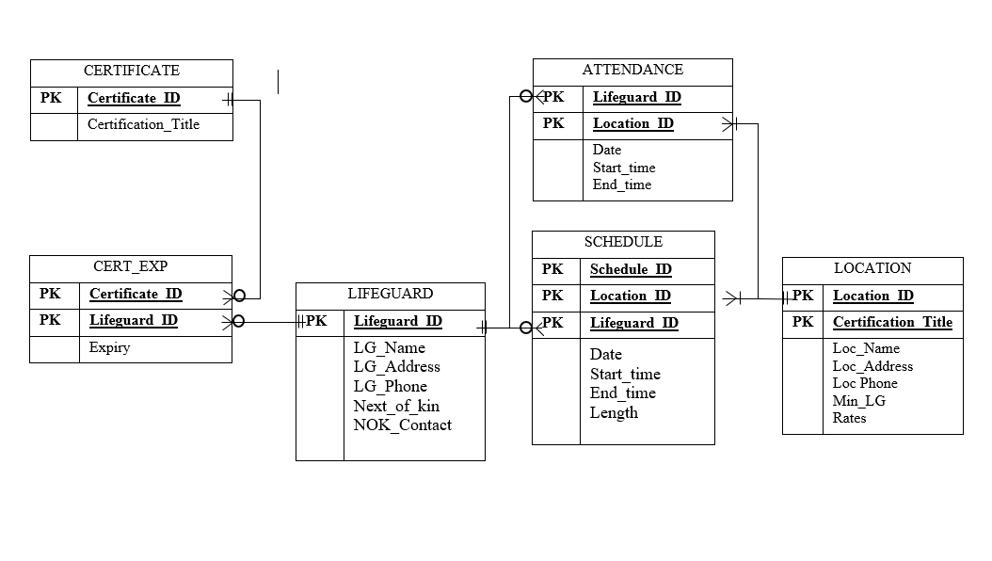

# Table Structure (3NF)

**LIFEGUARD**(Lifeguard_ID, LG_Name, LG_Address, LG_Phone, Next_of_Kin, NOK_Contact)

**CERT**_EXP(Certificate_ID, Lifeguard_ID, Expiry)

**CERTIFICATE**(Certificate_ID, Certificate_Title)

**ATTENDANCE**(Lifeguard_ID, Location_ID, Attendance_ID, Attendance_Date, Start_time, End_time)

**SCHEDULE**(Lifeguard_ID, Location_ID, Schedule_ID, Schedule_Date, Start_time, End_time, Length)  
**LOCATION**(Location_ID, Location_Name, Location_Address, Location_Phone, Minimum_LifeGuard, Rate)

# Table Design

4.1 LIFEGUARD

LIFEGUARD table contains particulars of each lifeguard, including name, address, phone number, next-of-kin and next-of-kin's contact number. The Lifeguard_ID is primary key.

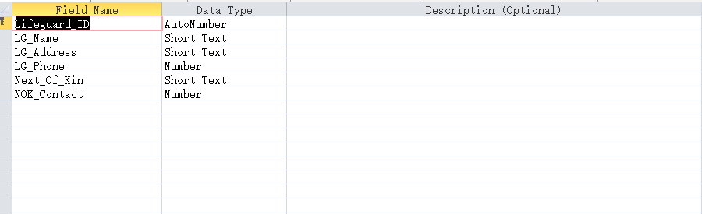(Design View)

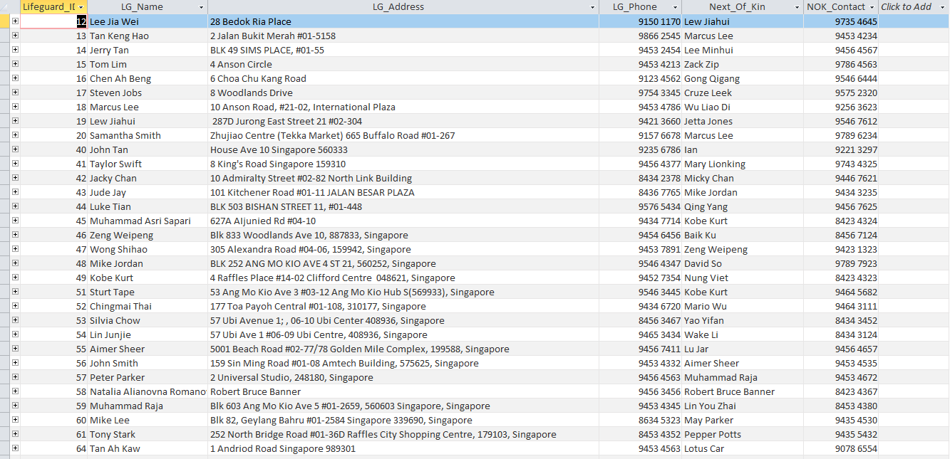

LIFEGUARD table with data

4.2 CERT_EXP

CERT_EXP table contains each lifeguard’s certificates and their expiration dates. Lifeguard_ID and Certificate_ID are the composite key.

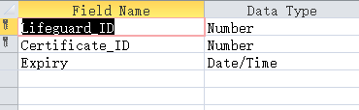

(Design View)

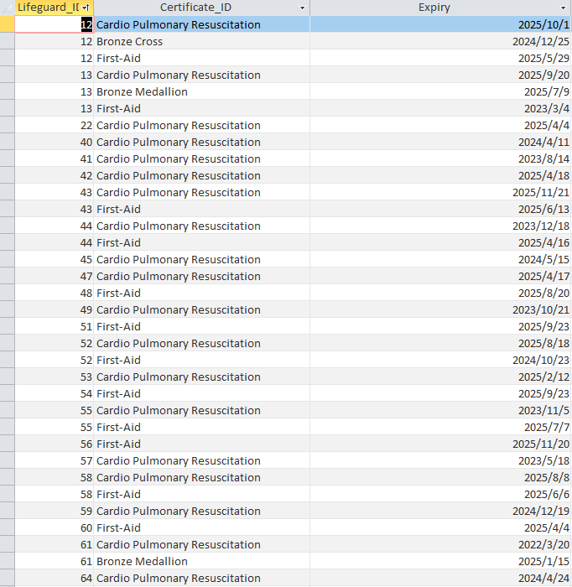

CERT_EXP table with data

4.3 CERTIFICATE

CERTIFICATE table contains certificate ID and the title of each certificate. Certificate_ID is the primary key.

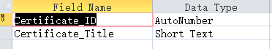

(Design View)

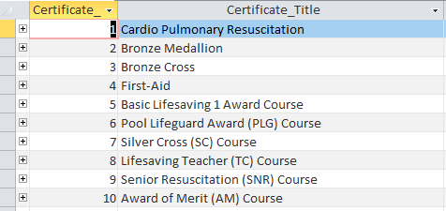

CERTIFICATE table with data

4.4 SCHEDULE

SCHEDULE table contains schedules of each lifeguard with the location, and details of schedules. Schedule_ID, Location_ID and Lifeguard_ID are the composite key.

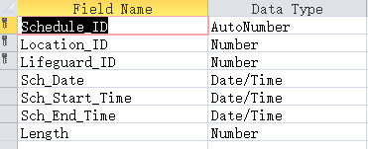

(Design View)

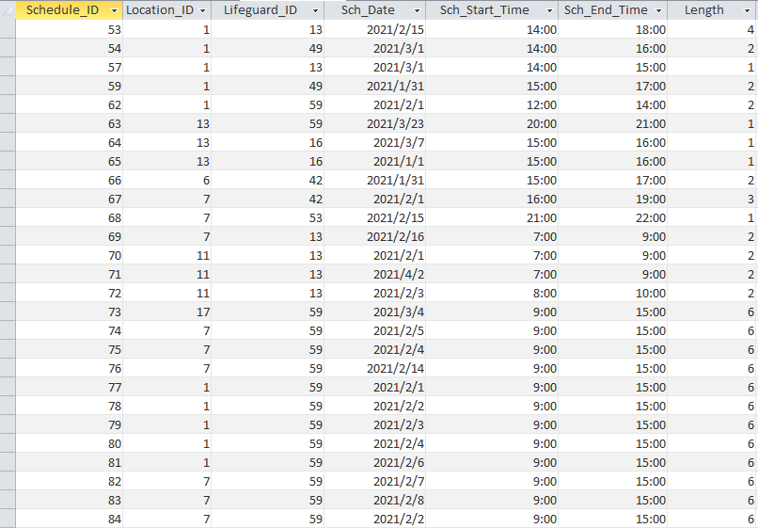

SCHEDULE table with data

4.5 ATTENDANCE

ATTENDANCE table contains attendance of each lifeguard with the location. Details of attendance are also included. Attendance_ID, Lifeguard_ID and Location_ID are the composite key.

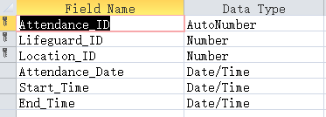

(Design View)

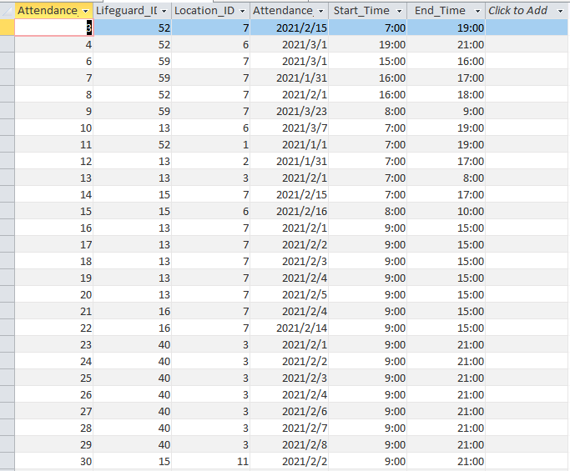

ATTENDANCE table with data

4.6 LOCATION

LOCATION table contains locations that lifeguards work at, and the details of each location. Location_ID is the primary key.

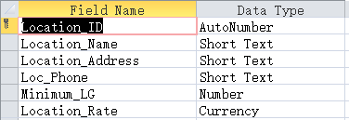

(Design View)

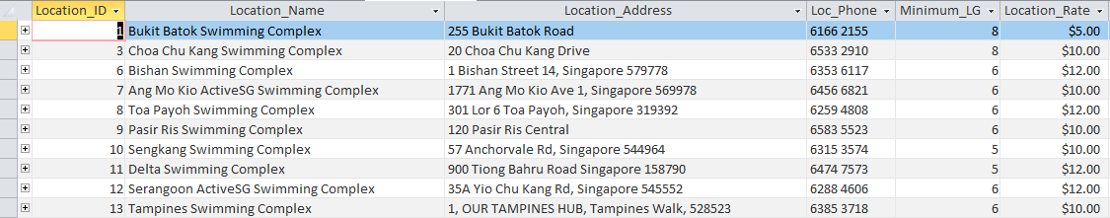

LOCATION table with data

1. Queries

5.1 Attendance-Location Query

Attendance-Location is generated to check whether employees have checked in and out their attendance at their work locations, did they report to their work on time or did not. This provides an overview of manpower in different locations in specific days.

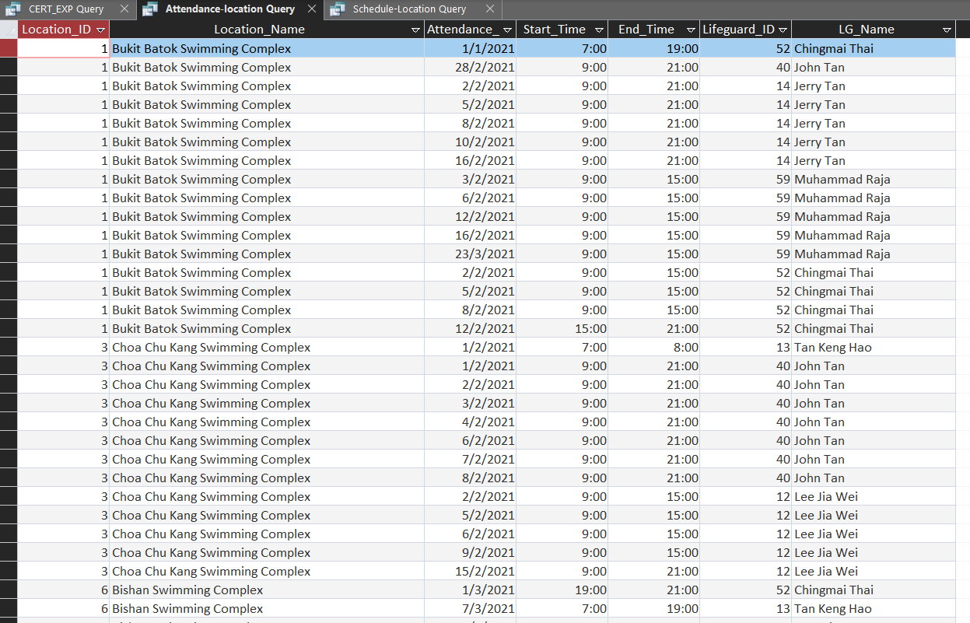

Attendance-Location Query

5.2 CERT_EXP Query

CERT_EXP Query generate the data of the current certificate that different lifeguards have, and to keep track of the expiry date to allow the management to remind them to renew or take up new certificate if required.

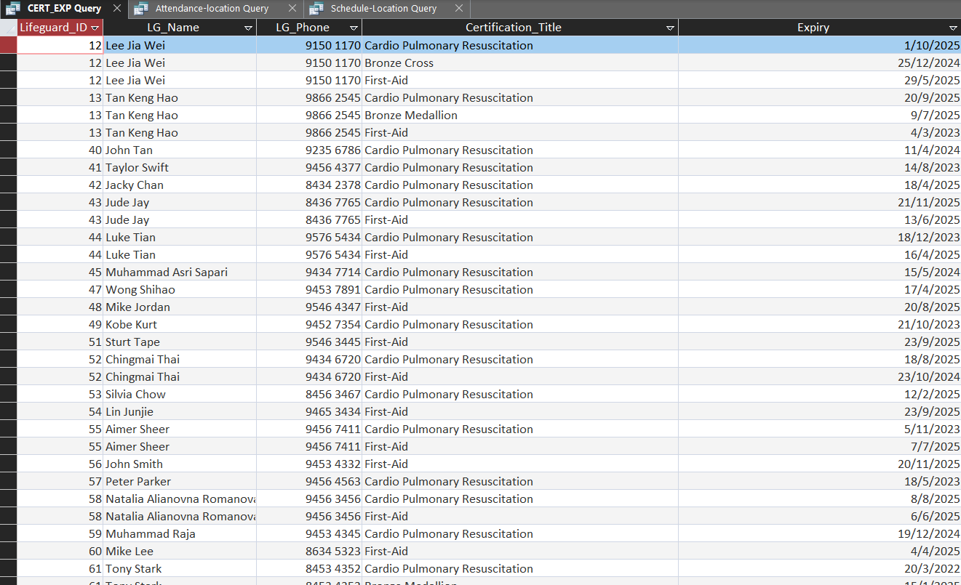

CERT_EXP Query

5.3 Schedule-Location Query

Schedule-Location query generates the schedule of different lifeguards repectively to the location, date, and working time. This helps the management to allocate the manpower efficiently while providing an overview workforce surplus or deficiency in work locations.

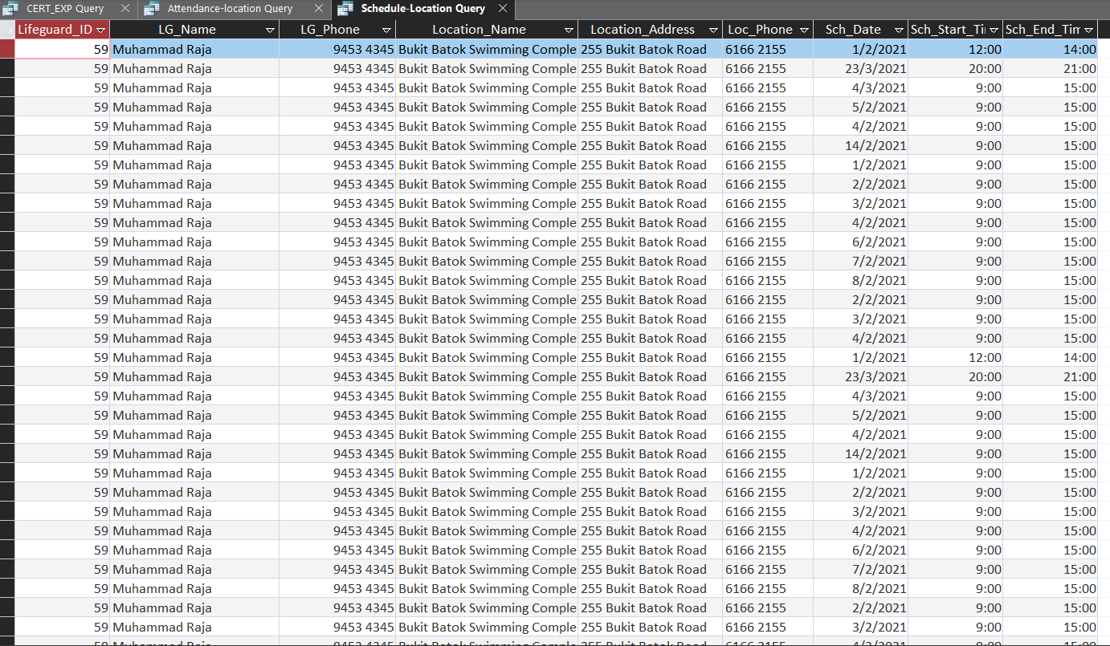

Schedule-Location Query

1. Forms

6.1 Attendance

This form is to enter new entry in Attendance table.

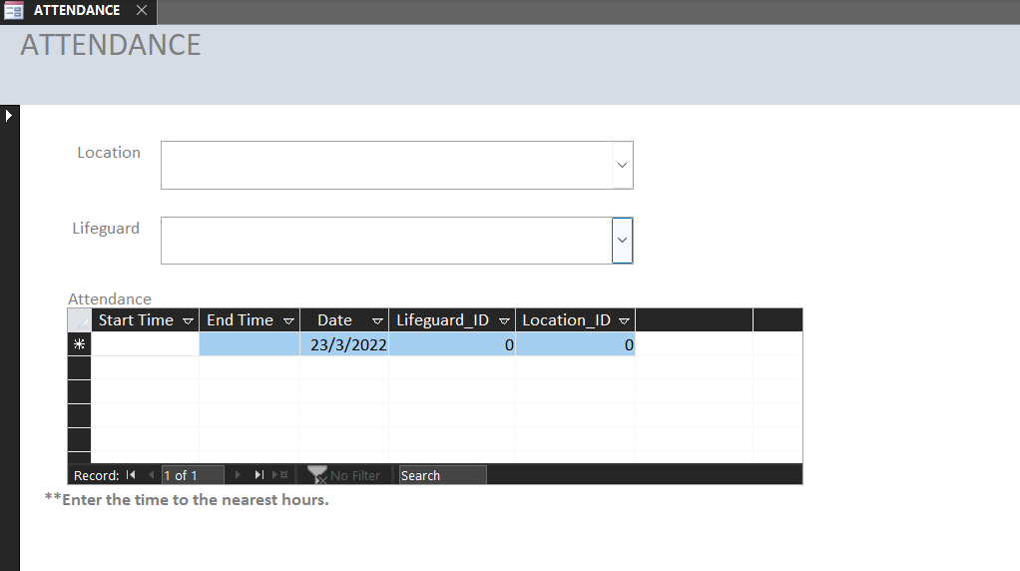

ATTENDANCE Form View

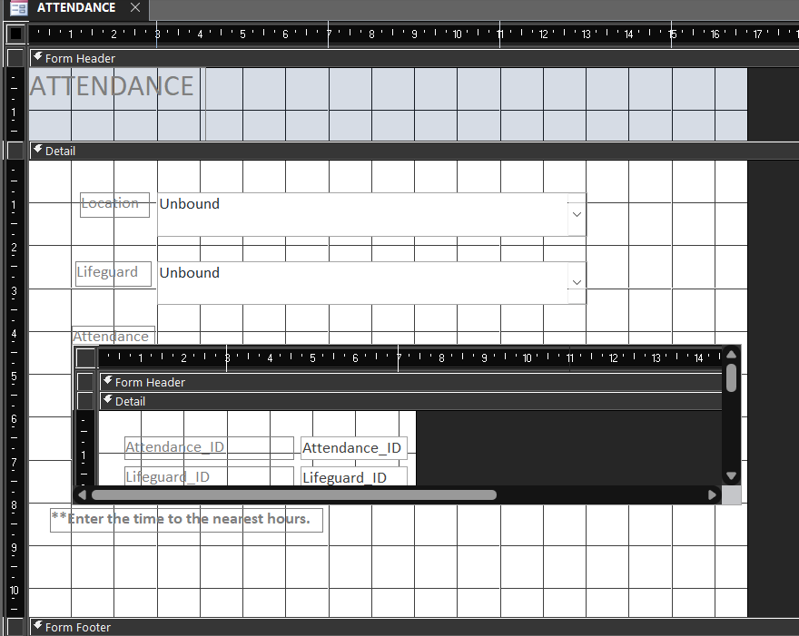

Design View

6.2 Attendance Subform

This Subform is linked to ATTENDANCE main form. It connects the Date and Time to the Lifeguard ID and Location ID of the relationship. Users are reminded to enter data in the main form and not subform.

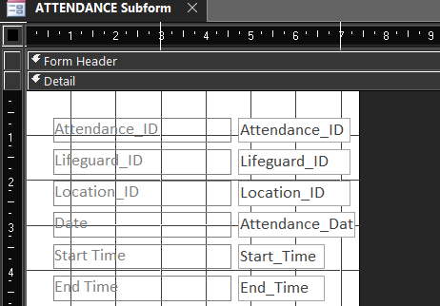

Design view

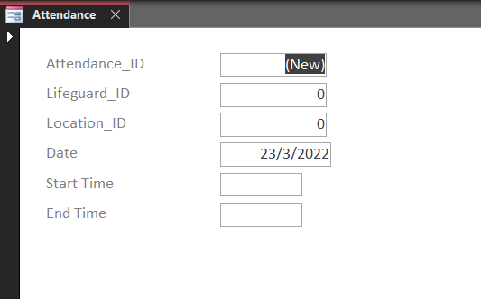

Form view

6.3 Certificate

This form stores data of new certificates that the company requires the lifeguard to have. When a new certificate is entered in CERTIFICATION_Title, the form will automatically generate the next number under CERTIFICATION_ID base on the CERTIFICATION table.

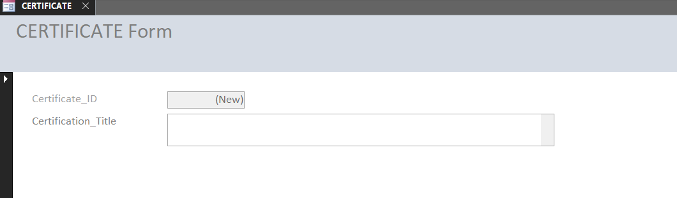

Form View

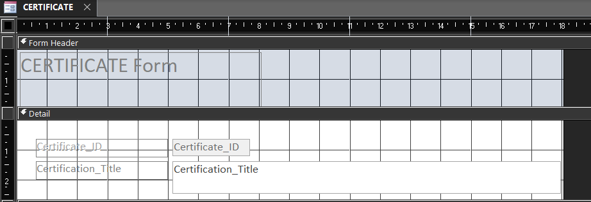

Design View

6.4 CERT_EXP Sub form

This form helps to record the certificates and the expiry date from newly acquire lifeguard.

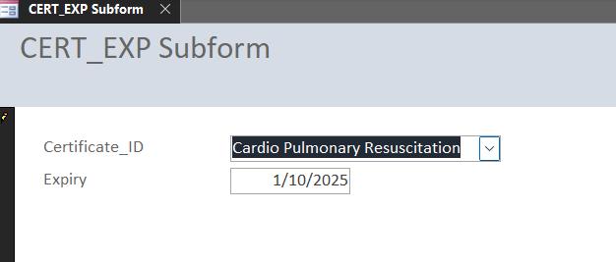

Form View

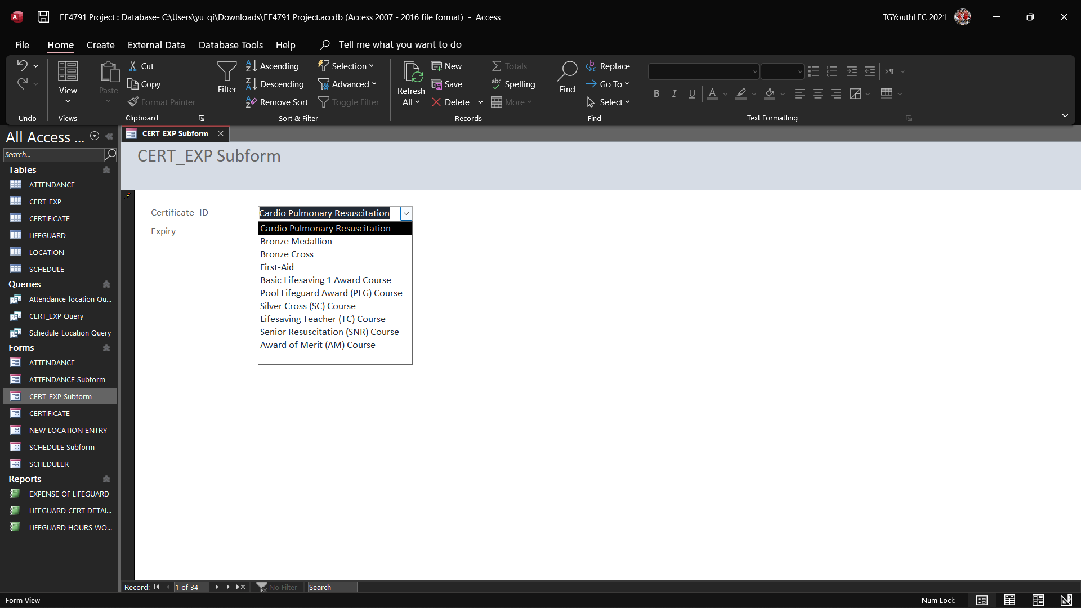

Dropdown List

6.5 New Location

This form records new work locations where company may open as part of business expansion or restructuring. The data is saved to the Location table.

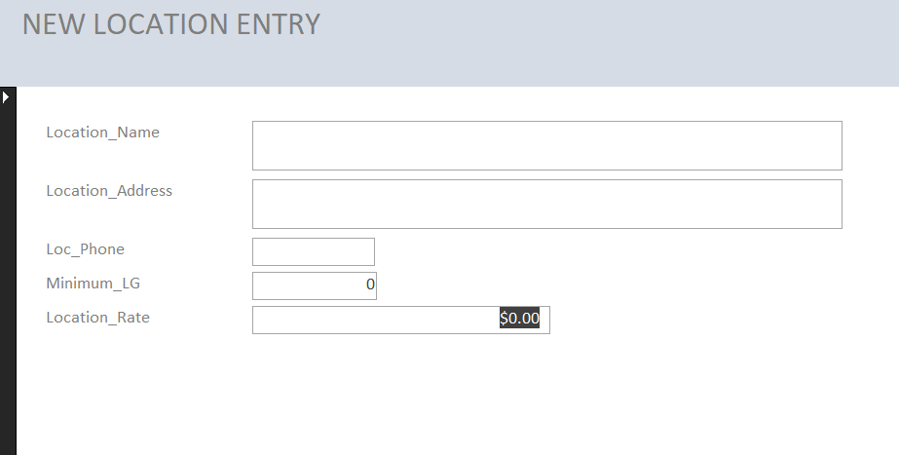

Form view

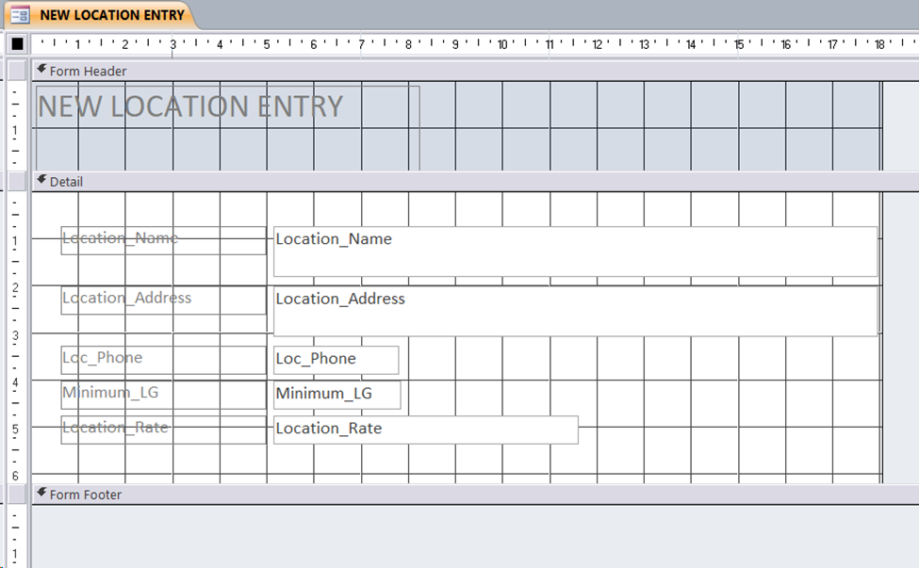

Design View

6.6 SCHEDULER

This form is used to schedule work slots for lifeguards. Data fields are saved to a new entry in the SCHEDULE table. To ensure lifeguards will not overwork resulting in fatigue, the company requires a work duration of not more than one shift per day for all lifeguards. Thus, this restriction has been implemented in the form in the following images.

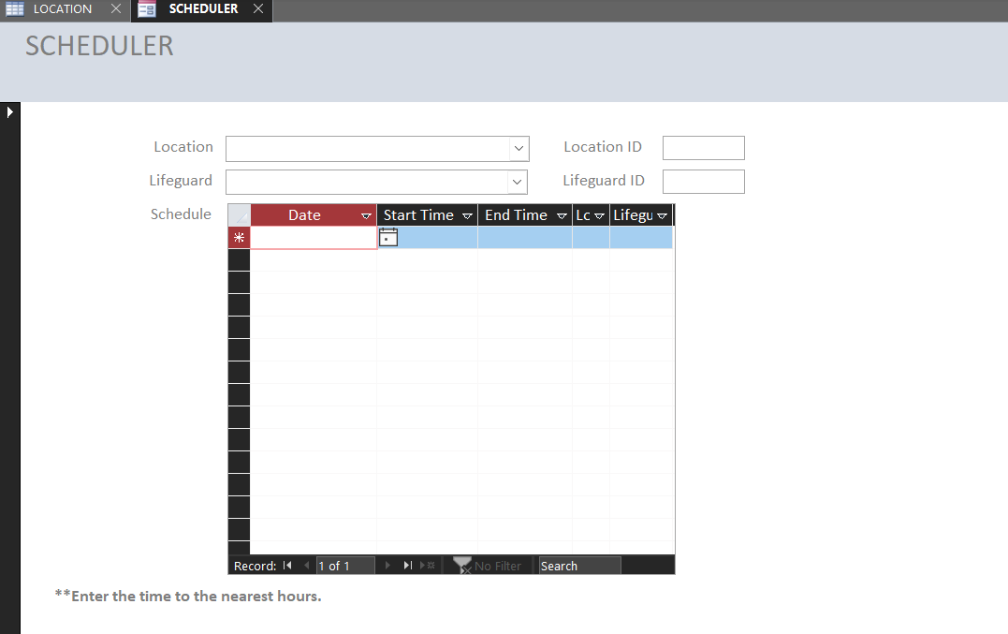

Form View

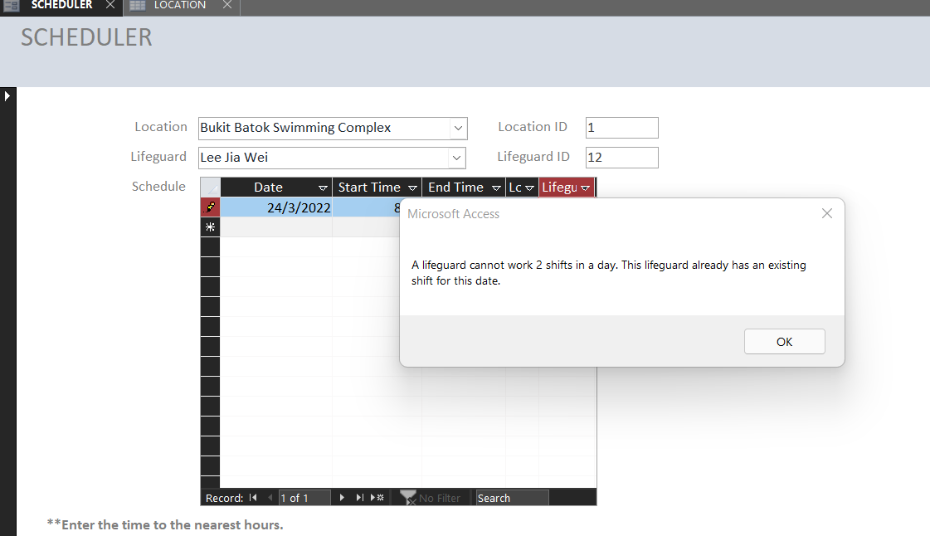

Rejected for working more than 1 shift in a day

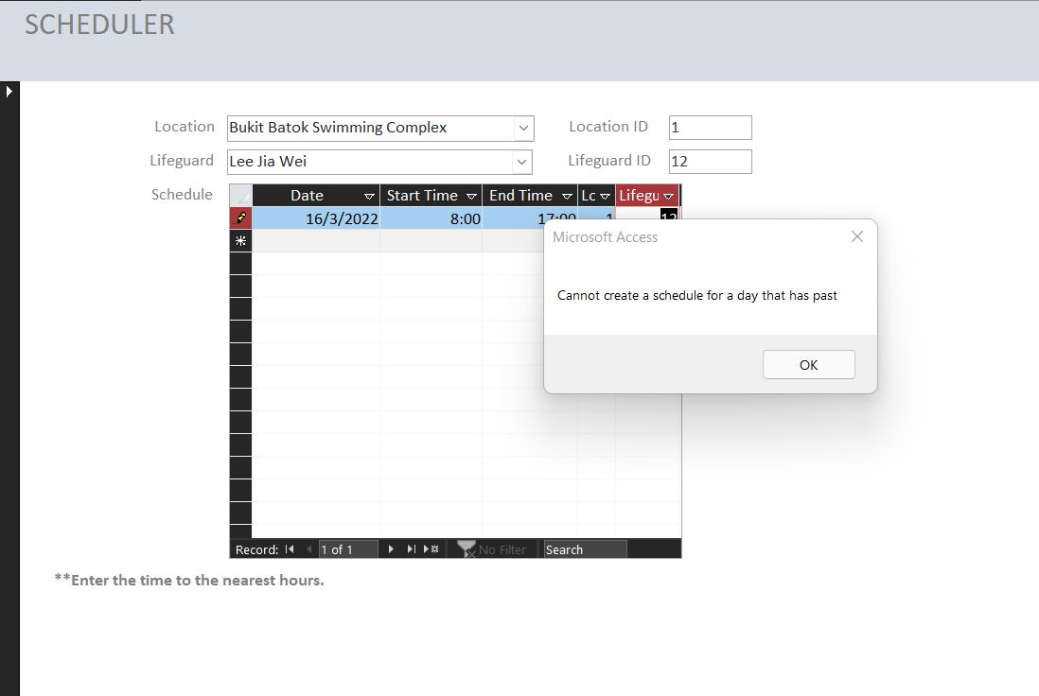

Rejected for entering past day

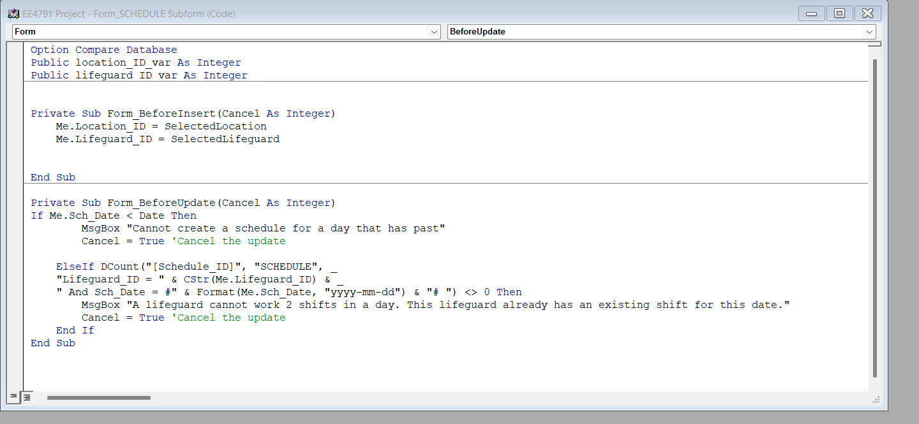Coding to ensure criteria are met

6.7 SCHEDULE Subform

This subform is linked to the SCHEDULER form. Entry must be made in SCHEDULER form.

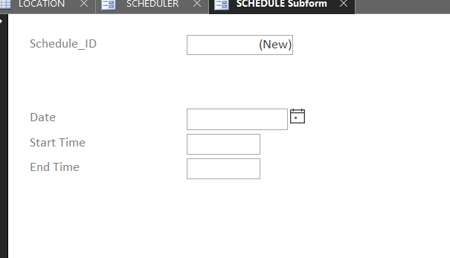

Form view

1. Reports

7.1 COST OF LIFEGUARD

This report states that, at each location, the hourly rate for lifeguards to work, planned schedule of each lifeguard including date and length of work, and the calculated cost. This report can be used to account for the amount of payment required from each location, splitting by each working session.

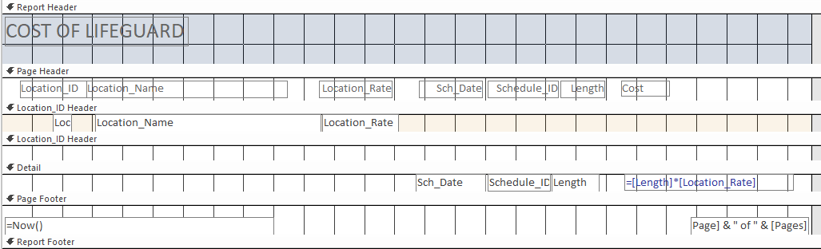Design View

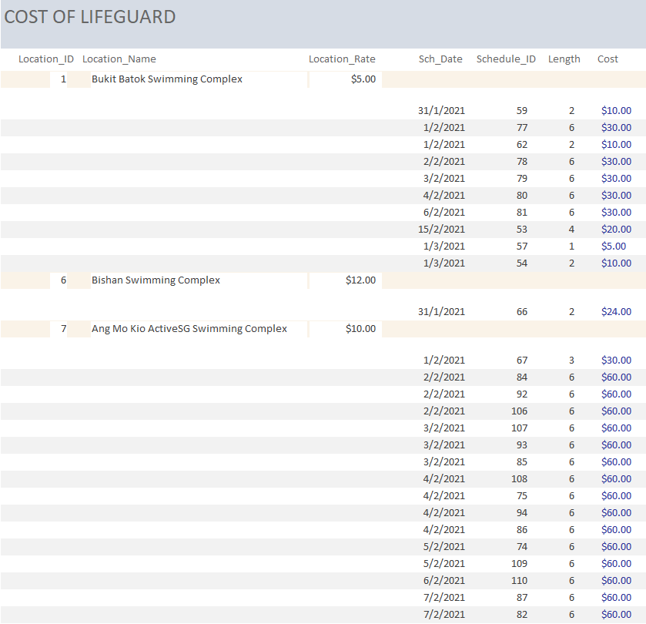Report view

7.2 LIFEGUARD HOURS WORKED

This report states attendance date, start time and end time for each lifeguard, and displays the calculated hours worked of the lifeguard for each session. This report can be used for monitoring lifeguards’ working length for each attendance, and help to better schedule their working slots in the future.

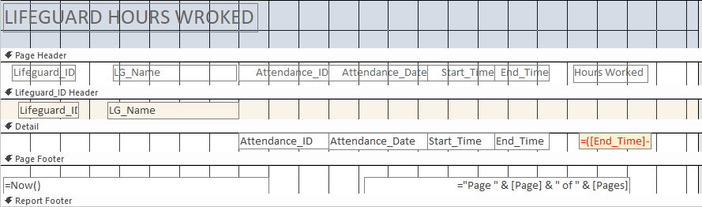Design view

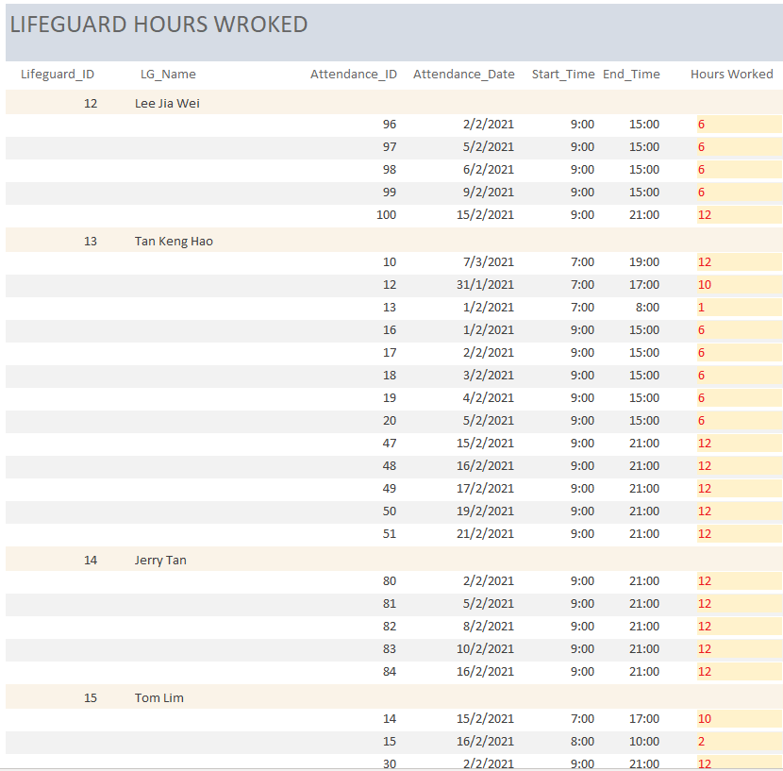Report view

7.3 LIFEGUARD CERTIFICATE DETAILS

This report states the certificates owned by each lifeguard, the expiry date of certificates, and days left for certificate to expire. The report also checks if a certificate expires. This report will be helpful when overseeing the qualifications of each lifeguard, and help to check whether a lifeguard has expired certificate to avoid allocating work to not qualified lifeguards.

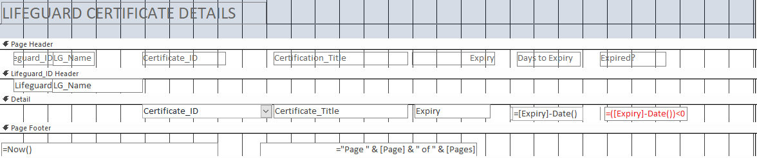Design view

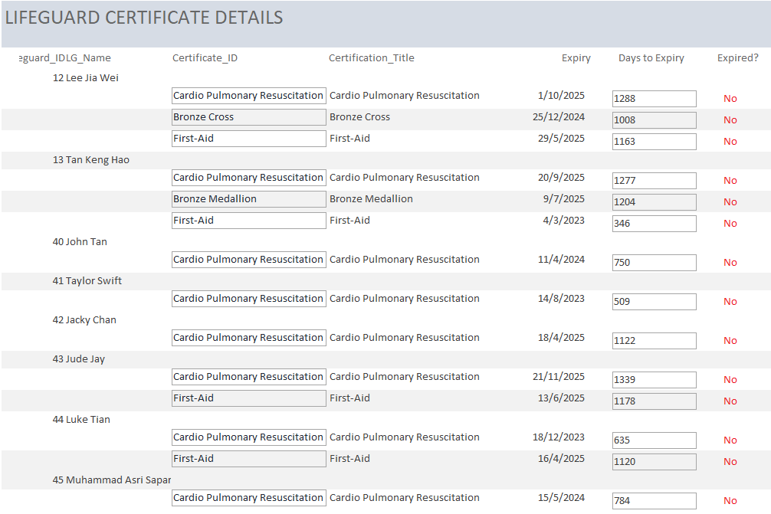Report view

# Future Improvements and Implementations

These are the areas that we believe we can improve to enhance the user experience upon future upgrades.

## **8.1 Tables**:

## 8.1.1 Employee type, lifeguard payment Table

Currently, we do not have a table that specifies the contract of the lifeguard the company hired. Therefore, we can create this table to allow the company to differentiate FULL time and Part time lifeguard. This will also lead to a calculation for the monthly payment for full time and the part time lifeguard base on the number of hours they work.

## **8.2 Queries:**

## 8.2.1 Schedule-Location Query

Although the Location Table stores information on the minimum number lifeguards required to be on duty at each work location, the query does not issue a prompt if there were a lack of manpower. A separate query could be created to issue a notification for the HR manager to quickly deploy manpower to required locations.

## **8.3 Forms:**

## 8.3.1 ATTENDANCE Form

Currently, the time in Attendance form is required to be rounded to nearest hours. This might bring some inaccuracies in the time records. To ensure a more accurate timing and prevent either employees or the company from being shortchanged, the timing entries could be changed to actual record timings.

**8.4 Reports:**

### 8.4.1 NOK-CONTACT Report

In the event of a critical incident or emergency involving an employee, the Shift IC may need to contact the affected employee’s Next-of-Kin expeditiously. A NOK-CONTACT Report could be generated for the Shift IC to quickly refer to a full list of NOK information.

# Database Integration and Challenges

9.1 Database Integration

Database integration is the process of combining information from multiple sources, which creates a consolidated, easy-to-access database.

9.2 Challenges

During the process of performing the task, we have met many challenges.

Top three the biggest challenges:

1. Connecting several databases together.
2. Finding compatibility between diverse types of data.
3. Determine whether a group of data is meaningful in the integrated database.

To integrate another database into our current system, firstly, we need to examine the commonality between the new and old databases. For example, if we want to adapt a database of Singapore swimming complexes, the locations of swimming complexes will be the shared data. Then, we need to determine which groups of data in the new database are meaningful in the integrated database. Finally, we may connect the two databases with the help of the shared data.